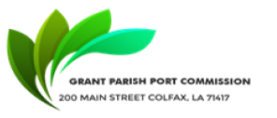

NOTICE OF PUBLIC MEETING
GRANT PARISH PORT COMMISSION
Notice Posted: October 18, 2023, at 9:00 AM
A public meeting will be held as follows:
DATE: October 19, 2023, at 9:00 AM
PLACE OF MEETING:
Grant Parish Police Jury.

AGENDA
- CALL MEETING TO ORDER
- ROLL CALL
- MOTION TO ACCEPT THE September Minutes
- OLD BUSINESS
- NEW BUSINESS
- MOTION TO ADJOURN

Charlene Anderson, Secretary
Grant Parish Port Commission
200 Main Street, Colfax, LA 71417

In accordance with the Americans with Disabilities Act, if you need special assistance, please contact Charlene Anderson at (318) 627-3157 describing the assistance that is necessary.

